LINKAGE AND LEVERS

Adjustment
Locking method
Determining wear and how to rectify
Operating of links and levers
Maintenance
INTRODUCTION

Linkages and levers play a major role in operating a winder. Without linkages and levers the brakes and clutches cannot operate. The Driver would not be able to move the winder without levers, which in turn operate the links to the servo, brakes and clutches
Therefore it is essential for you to know the function and operation of all the links and levers on a winder, also the maintenance required and how to determine wear or incorrectly adjusted components, which will cause malfunction of the brakes, clutches, servo and safety devices.
In this module we will discuss the linkages and levers in the following order:

Adjustment.
Locking methods.
Determining wear and how to rectify.
Operation of links and levers.

Clutch and brake operation
Links to servo

ADJUSTMENT

The first and most important point is, never make any adjustment on any linkage or lever while the winder is in motion.
Then any adjustment has to be made to the winder, notify the Driver and enter the work to be done in the Driver’s logbook and Machinery Record Book, as any adjustment could alter the operation and behavior of the winder. For example, if you adjusted the brakes, the brake times could change. The slow braking could be faster or slower than normal. On completion of any adjustments the winder must be test-run by the Driver.
Adjustment of the different components is done at different points, but basically whether it is the brakes, servo or liquid controller, the procedure is the same.
Firstly you must know why, where and how to do adjustments, and to use the correct tools.
When making adjustments care must be taken to ensure that the threaded ends of a rod are equally screwed into the clevises or turnbuckles. By not having enough threaded rod screwed in to the clevis or turnbuckle, thread could strip, causing failure of the operational devices. This can cause serious accidents and damage to the winder, conveyances and shaft.

Fig. 1 illustrates the correct adjustment.

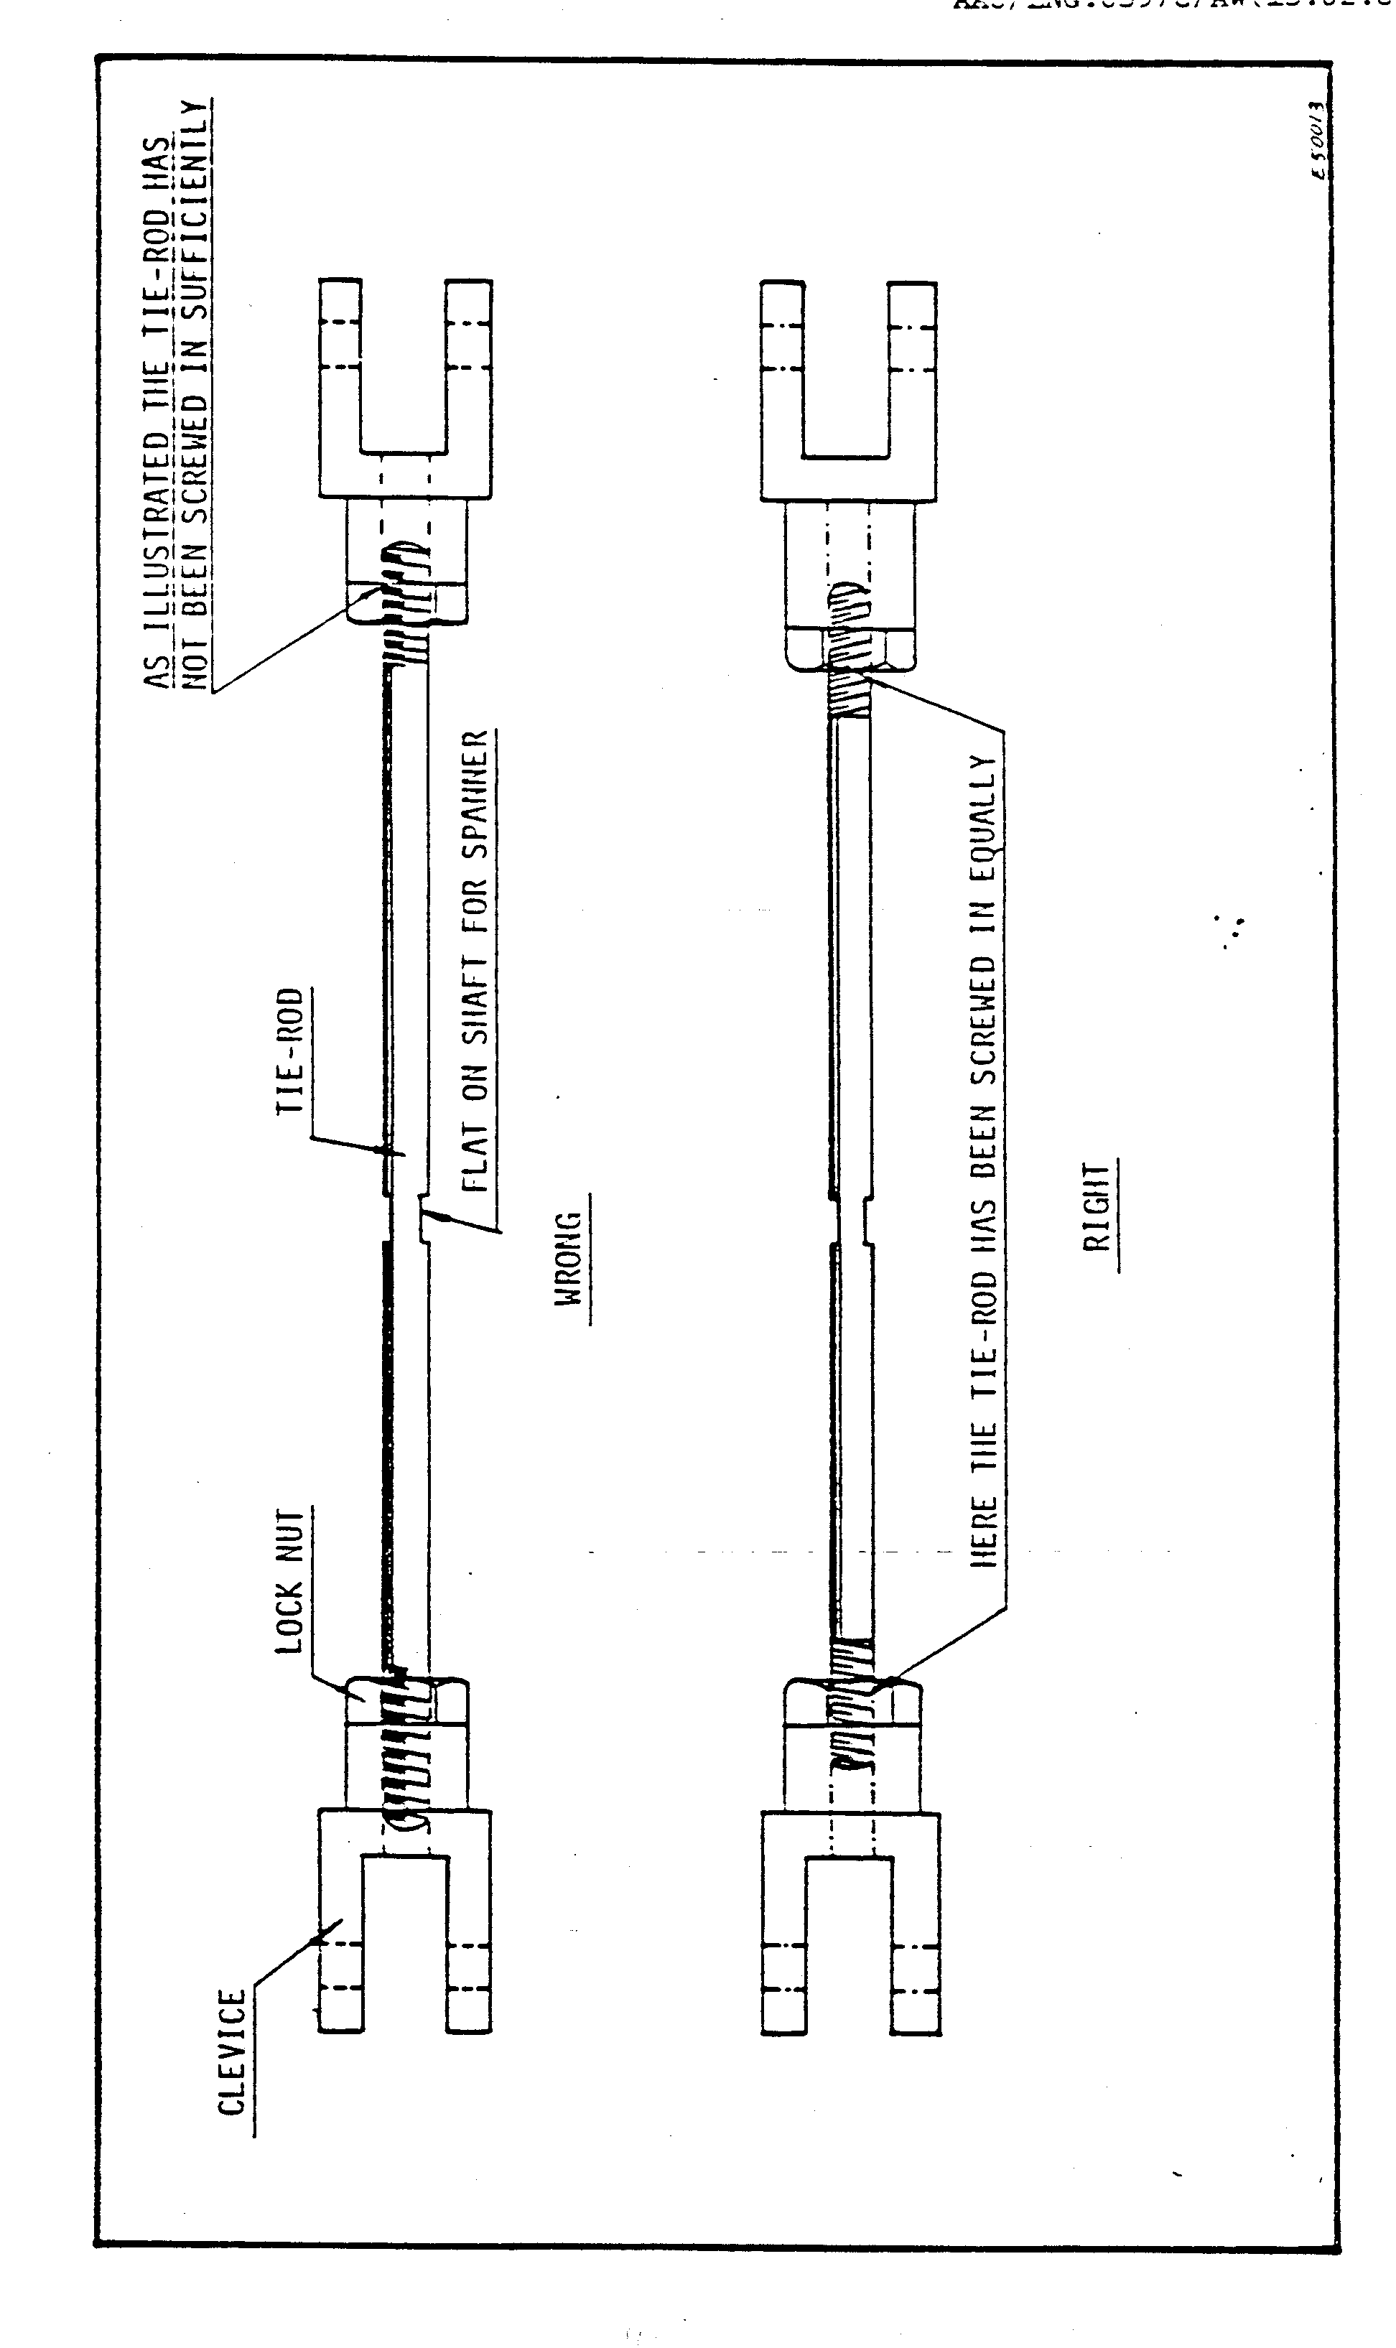
LOCKING METHODS

Locking of links and pins is very important when a linkage, as shown in Fig. 1.,has been set to perform a specific function. The setting must remain constant. Therefore different methods of locking the linkages and pins are used on the winder.
In Figures 2, 3 and 4 a range of locking methods are shown namely:

- Lock nut on brakes and clevises
- Split pin on all brake pins
- Taper pin on link arms of liquid controller
- Groove and lock plate on brake pins
- Lock nut and split pins on humble hook
- Centre groove and locking bolt
- Parallel keys
- Taper keys on clutch arms
- Castle and nylock nuts

All the different methods stated need to be examined daily. If any of the above mentioned fail, or loosen, the winder could be affected in many ways. A missing pin will cause malfunction of the brakes, which could cause damage to equipment and serious injury. It is not always possible for you to just pinpoint the fault, a proper inspection must be carried out.

Fig. 2 illustrates all the locking methods.

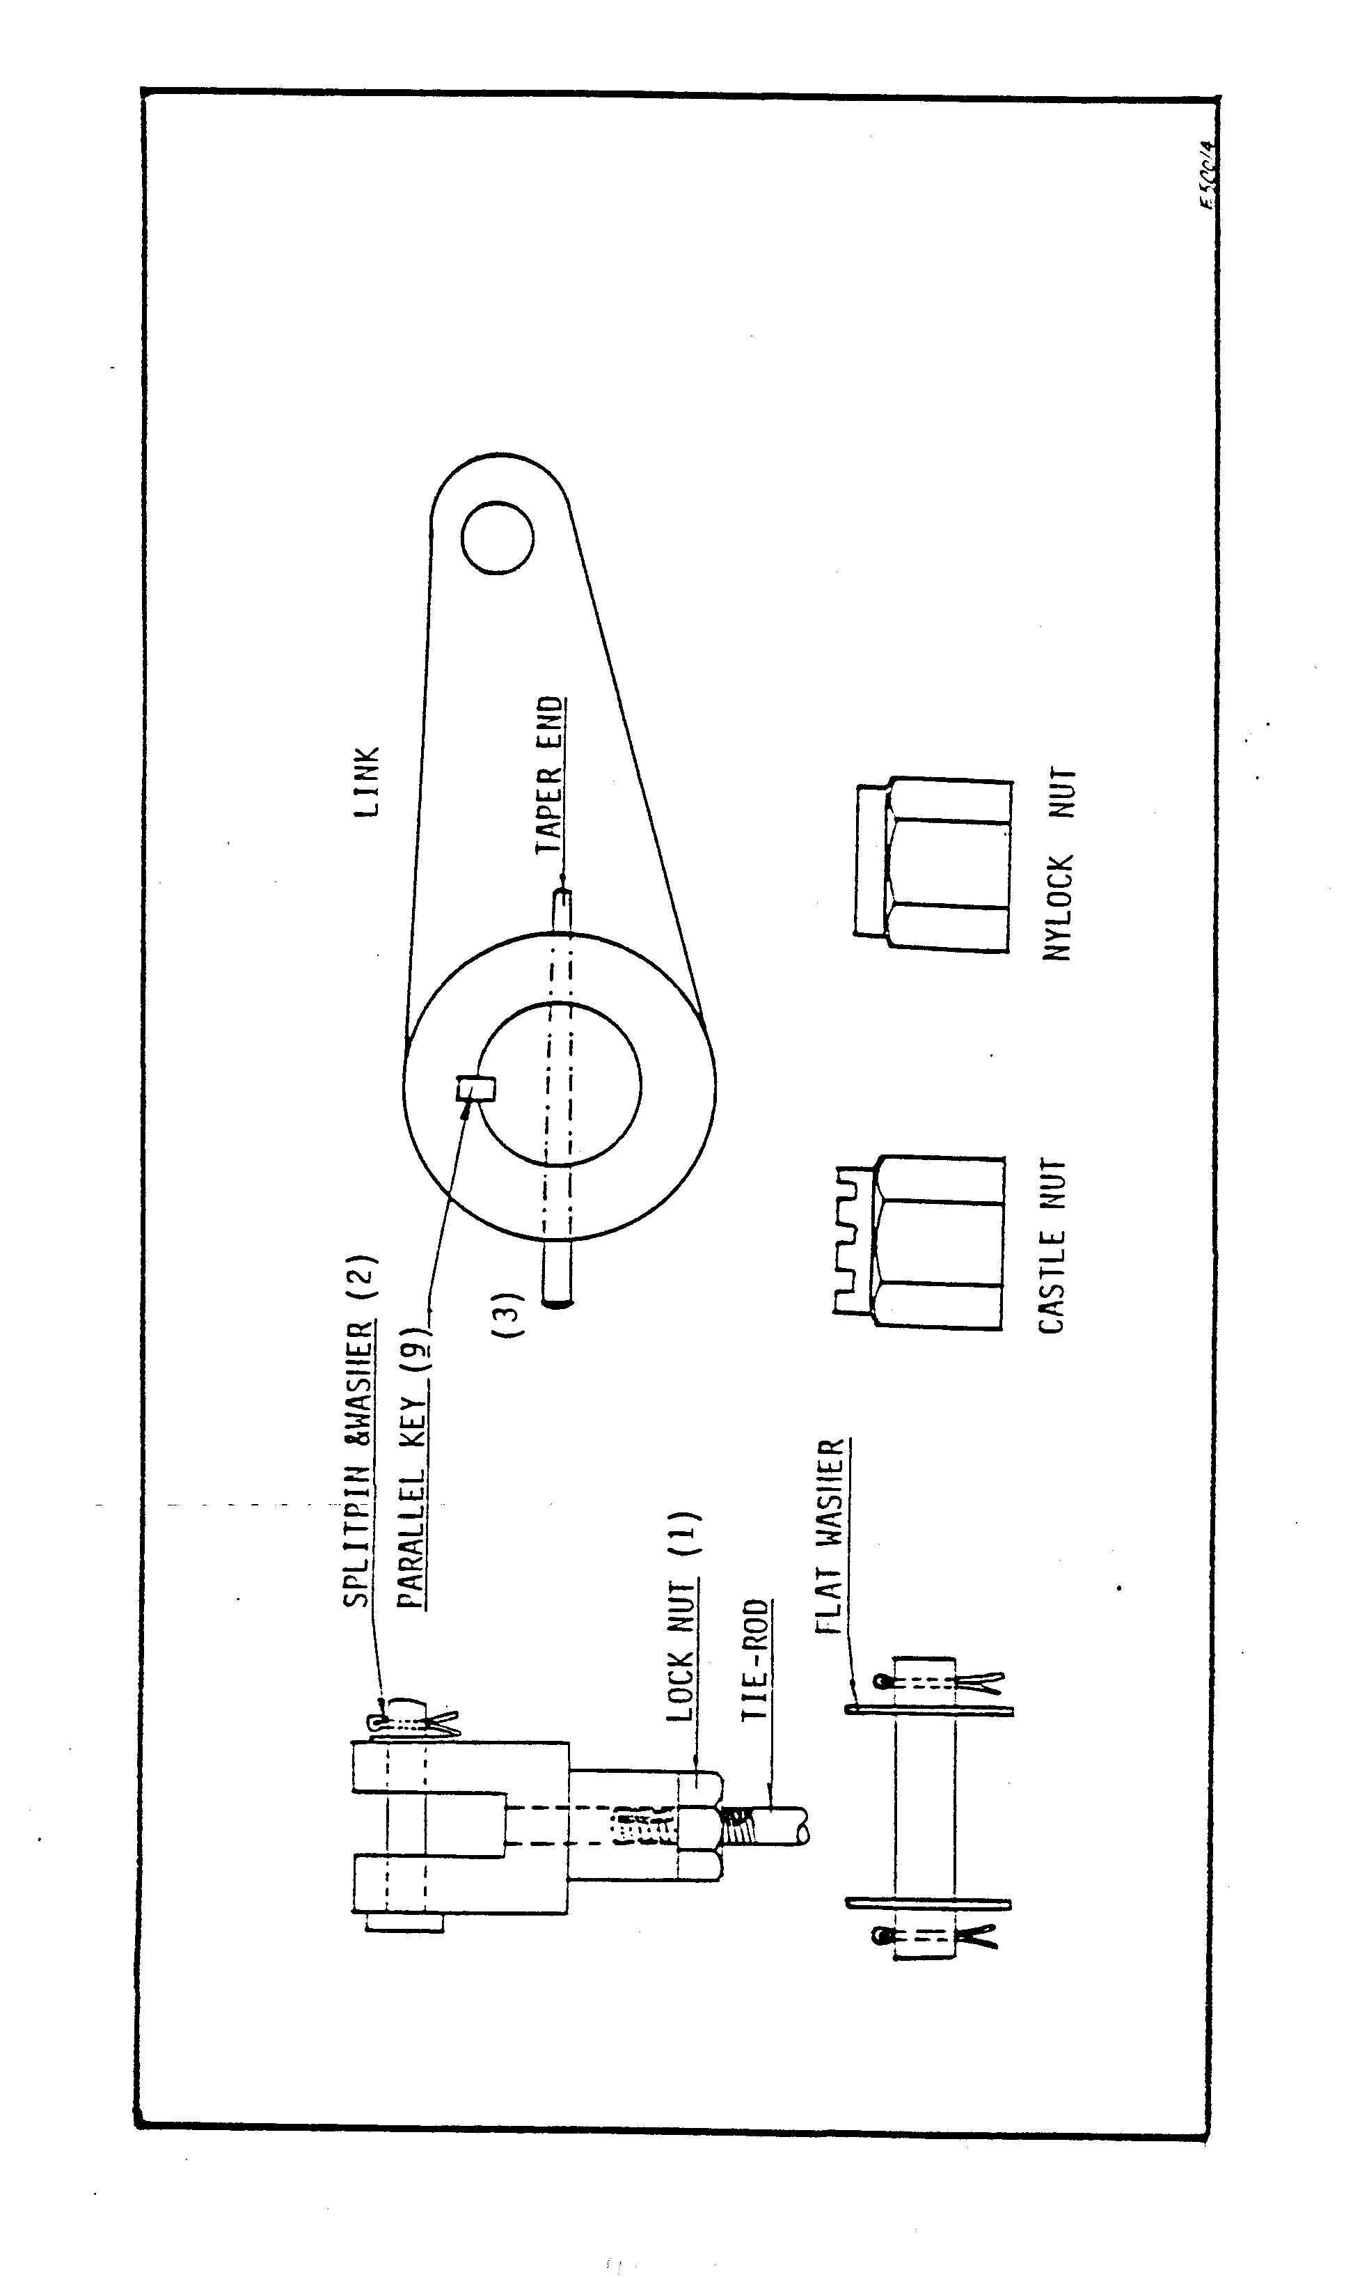
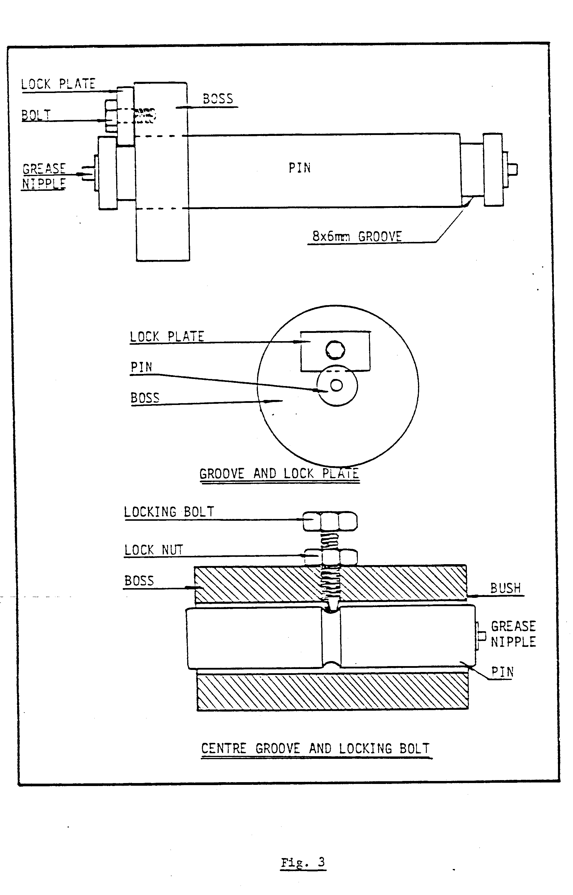
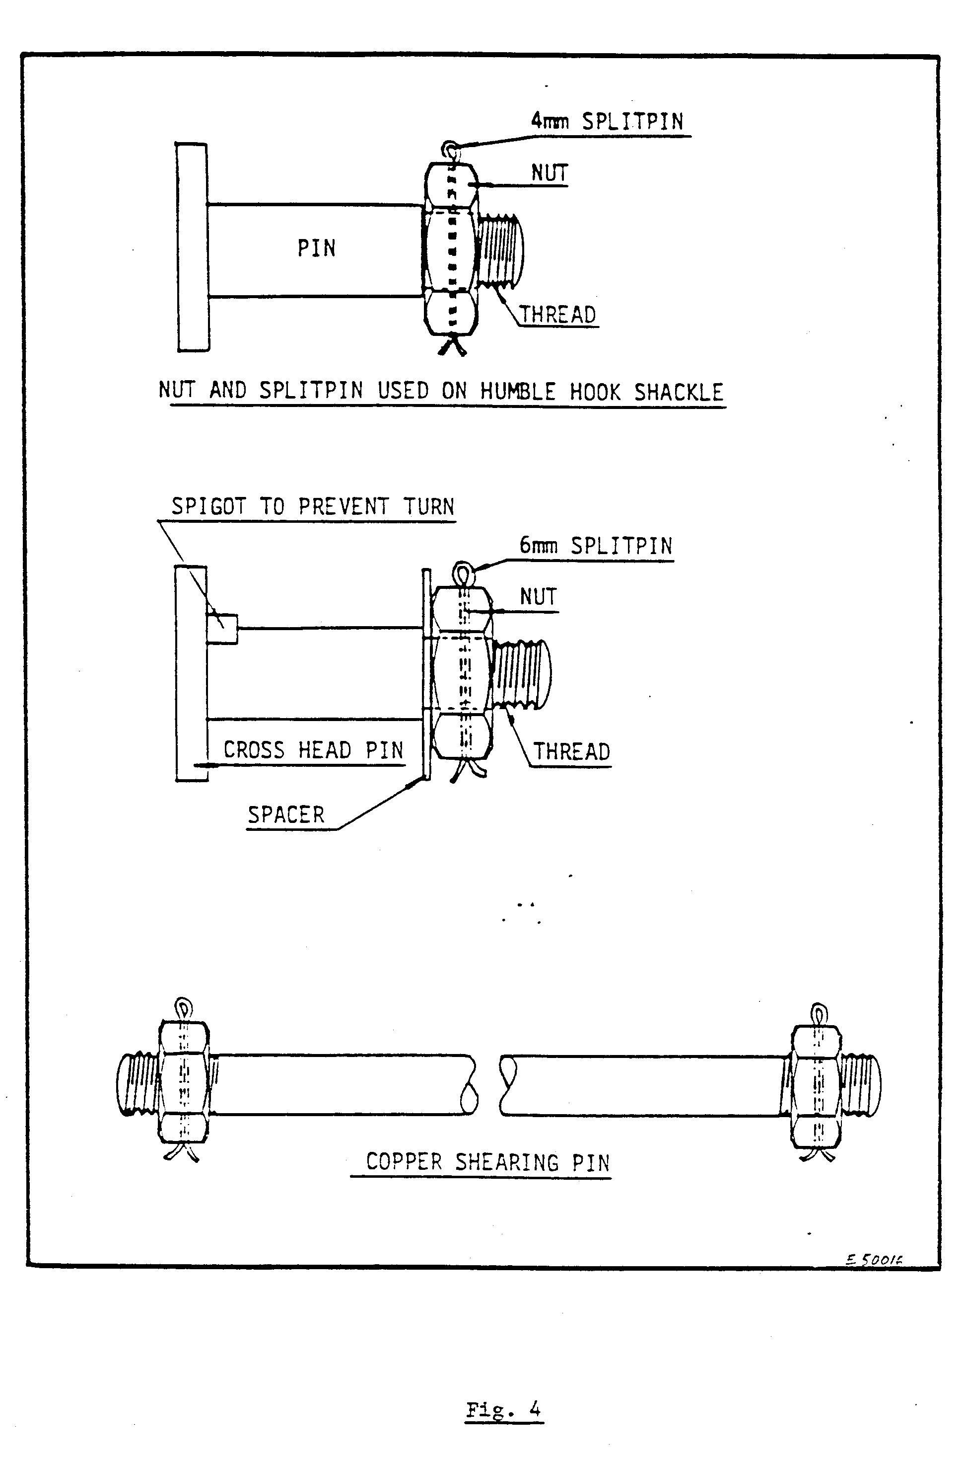
In Figures 2, 3 and 4 you can see why it is important to have a daily examination of all the locking methods. The last illustration, Fig. 4, shows pins used on the humble hook, which attach the winder to the conveyance via the rope.

DETERMINING WEAR AND HOW TO RECTIFY

Wear can be reduced to a minimum by examining and lubricating correctly and regularly.
To determine wear is quite simple. For instance, tell the Driver to move the control lever forward and check the travel before there is contact. If the lever has to be moved a considerable distance, this indicates wear on the pins and clevises. If you start checking from the Driver’s lever to the servo you will find that each bit of wear adds to the total distance of travel of the lever before contact is made.
If wear is detected, change the worn parts. Spare pins, clevises and turnbuckles for the brakes must always be available in the winder store. Remember to renew the split pins.
Wear could, in some instances, be taken up by adjustment, but it is preferable to change the worn parts. IF there are no spares available, arrange to have them manufactured. Pins and turnbuckles must be approved by the Non-destructive Testing Department and date-stamped.
If you do change a damaged or bent tie rod, make sure that it has been tested and stamped.

OPERATION OF LINKS AND LEVERS
Under the heading “Operation of links and levers”, we will discuss the following:
- Clutch and brake operation
- Links to servo
Fig. 5 illustrates a Driver’s desk with all the instruments and levers shown.
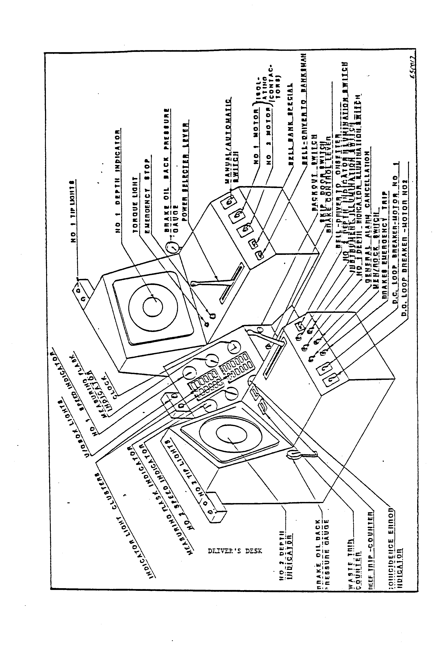
In Fig. 6 the levers on the footplate are shown.

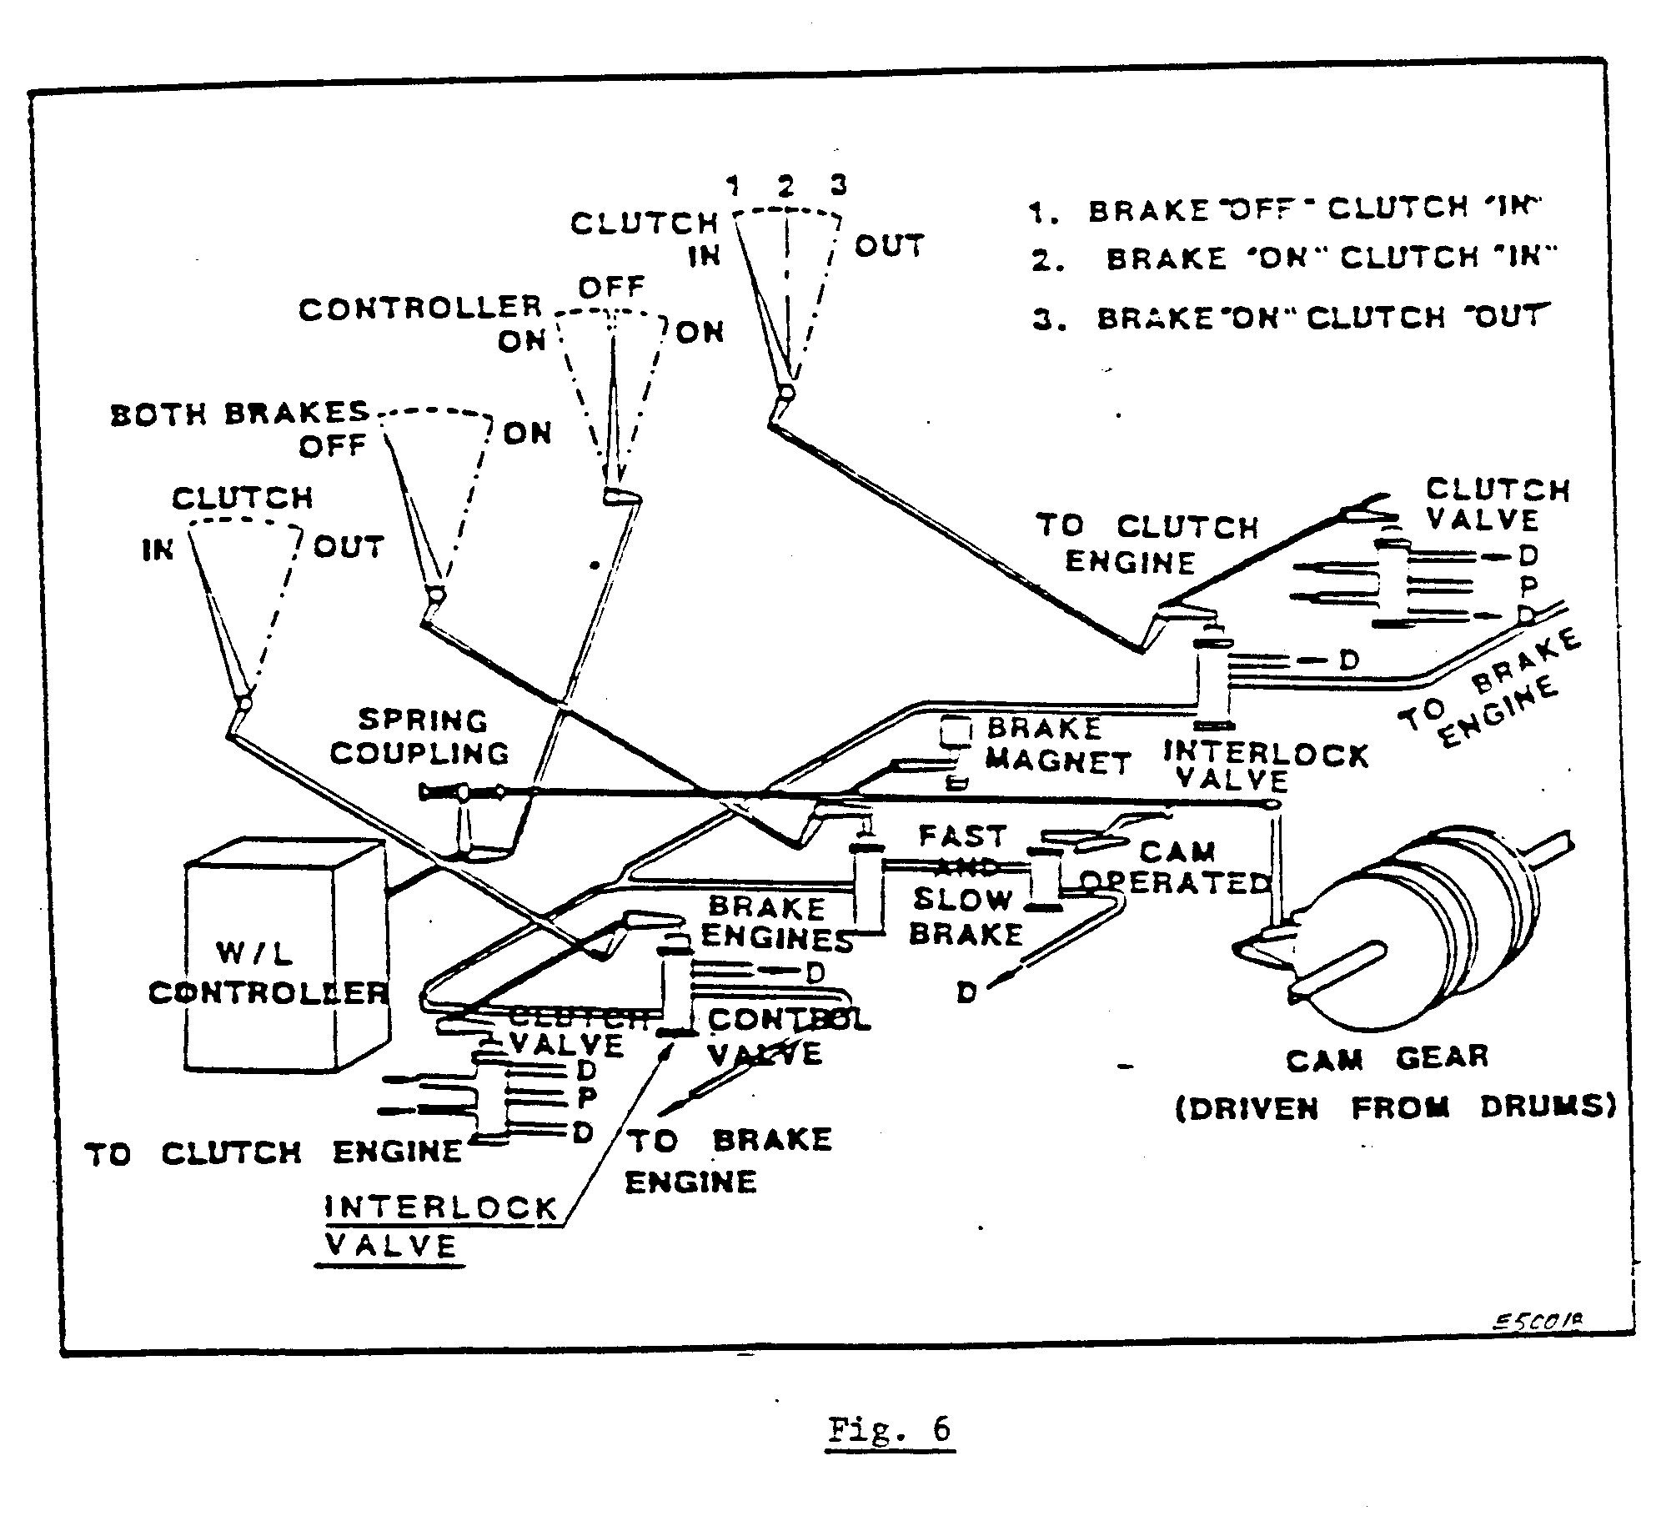
CLUTCH AND BRAKE OPERATION

When clutching, the Driver manipulates the brake and clutch control levers, which in turn, through links, activate the valves operating the clutch and brakes, as illustrated in Fig. 7.
The Mines and Works Act and Regulations No. 16.6.2 states:
“It shall be impossible to unclutch any winding drum unless the brake or brakes of such drum are fully applied and it shall be impossible to release the brake or brakes of such drum until the clutch is fully engaged and securely locked”.

On some winders this is achieved by having one lever to operate the individual drum brake and clutch. As can be seen from Fig. 7, the first movement of the lever applies the brakes and the second movement withdraws the clutch. In the reverse operation on the clutch is first engaged and then the brakes can be released.

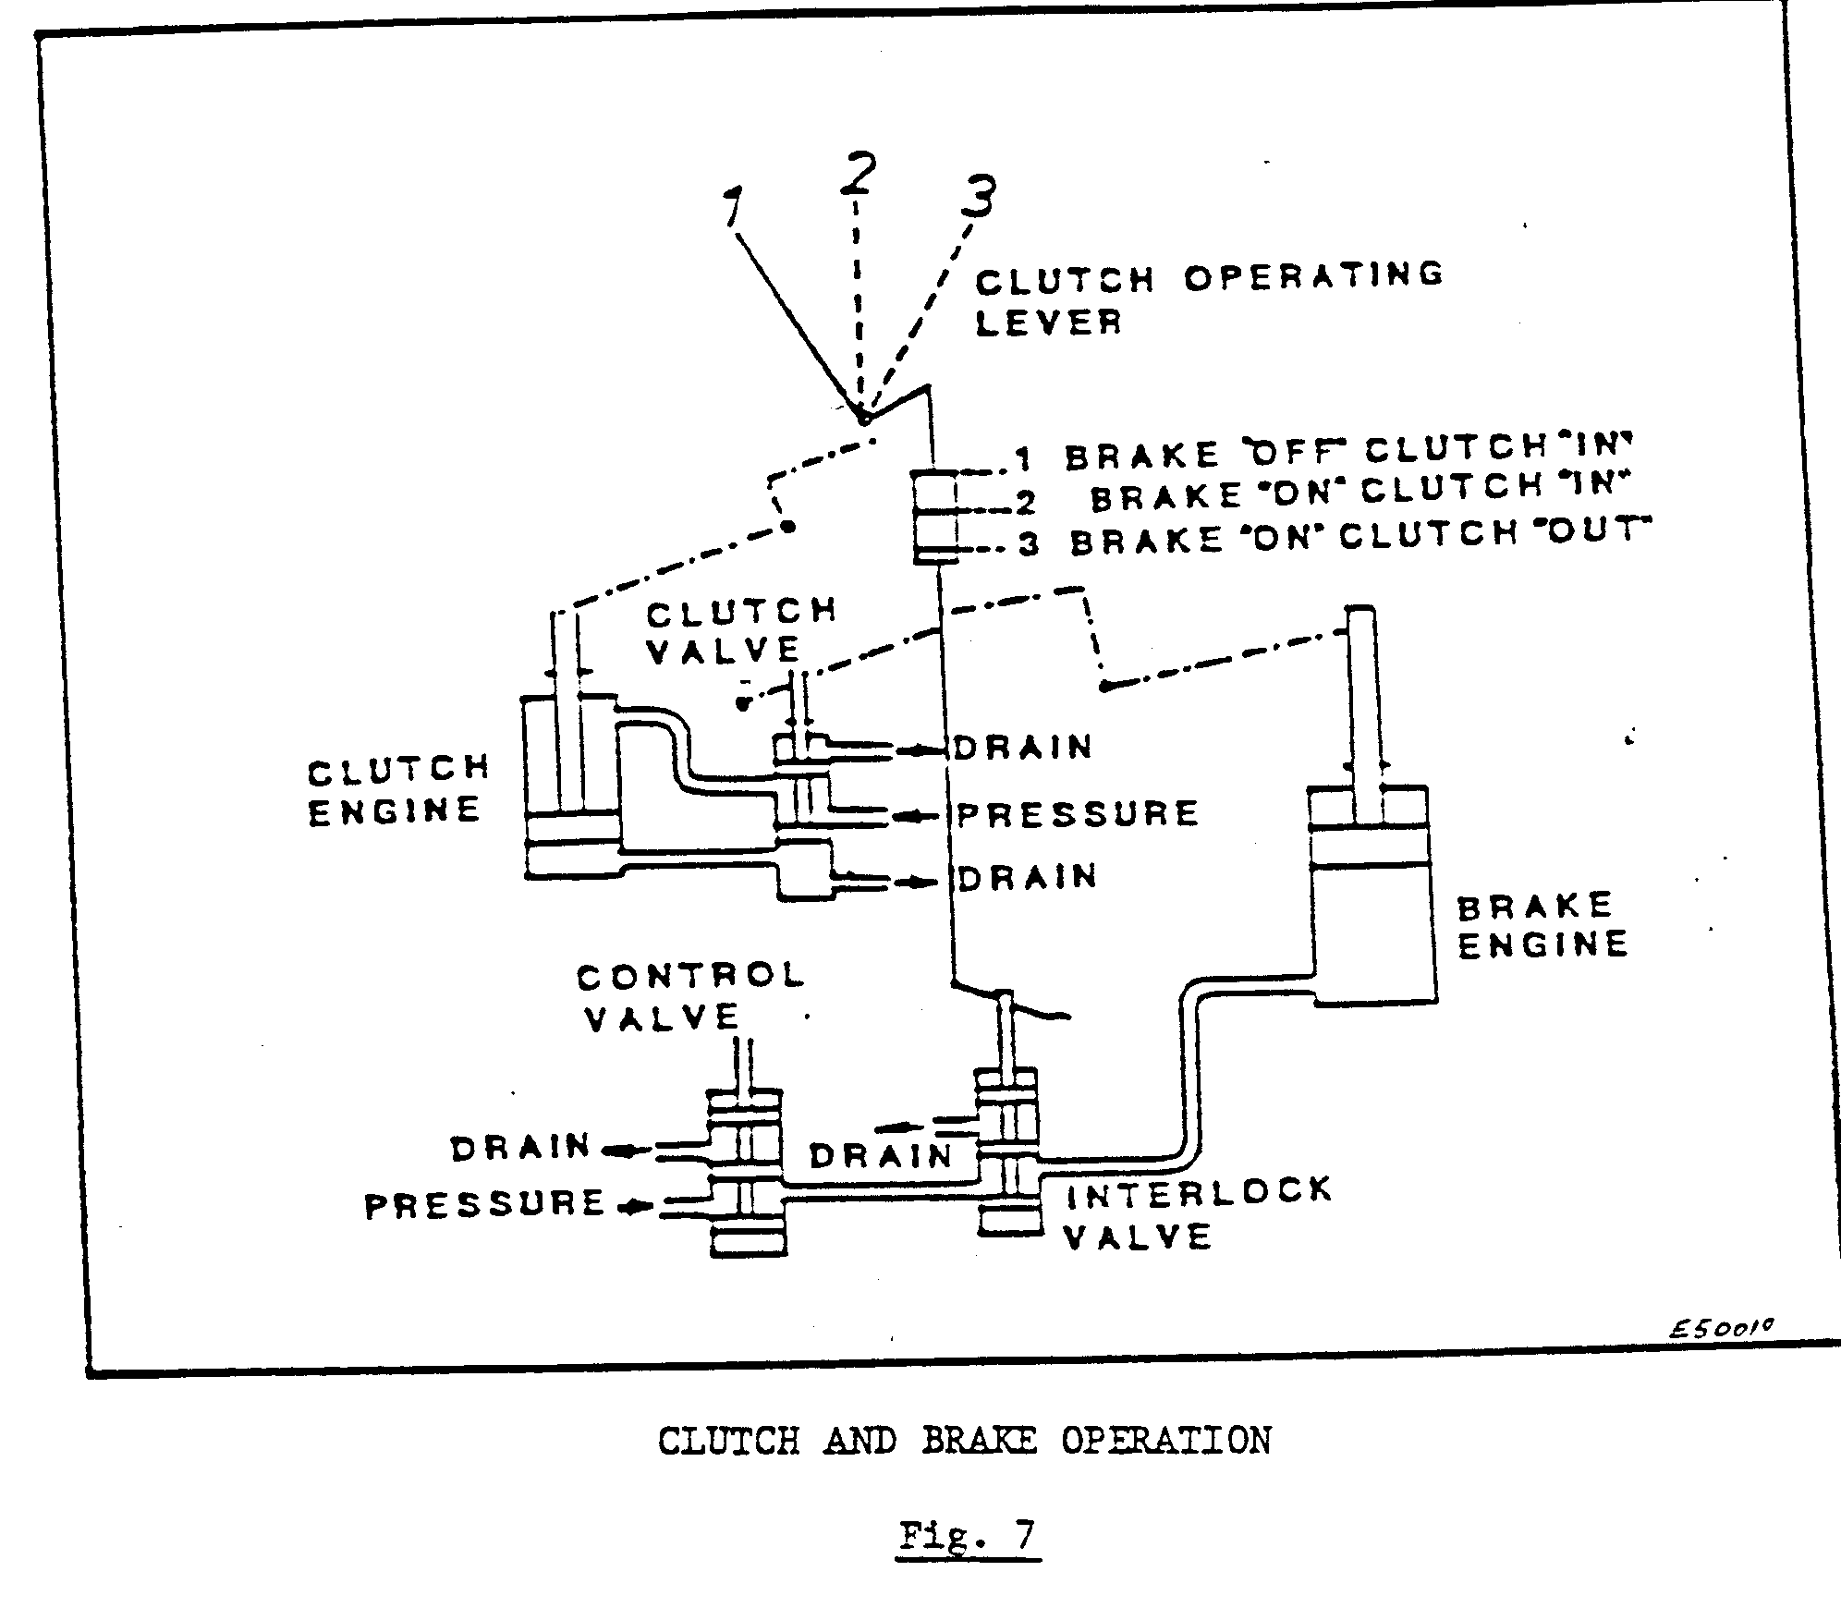
In Fig. 7, the actual operation of the clutch and brake is illustrated.

The valves shown in Fig. 7 are all operated through links which, in turn, are actuated by the action of the Driver when he moves either the brake or clutch control levers.
Fig. 8 illustrates a complete clutch and clutch arms which, when actuated by the Driver, either engages or disengages the whole unit.
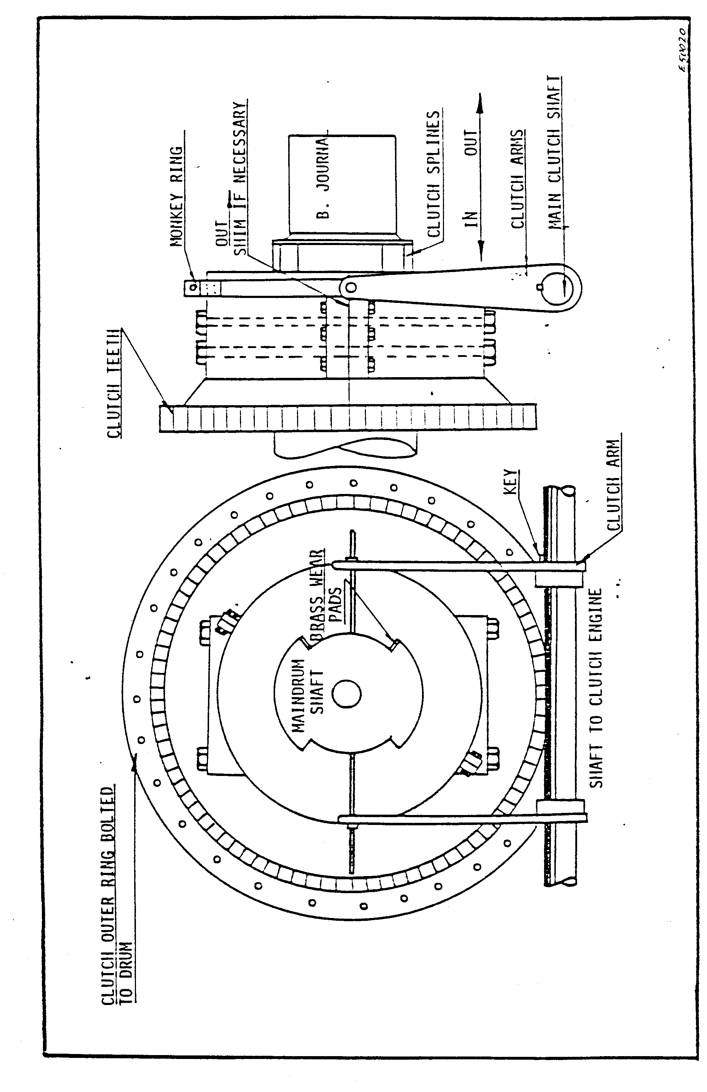
When the Driver releases the brakes, he moves the brake lever forward which moves the linkages connected to the brake engine valve.
The valve opens and the hydraulic oil actuates the brake engine which lifts the dead weight and releases the brakes. Then applying the brakes, the Driver pulls the brake lever back which, through the linkages, actuates the valve which dumps the oil back to the tank of the brake engine, and the drop of the dead weight applies the brakes as shown in Fig. 9.

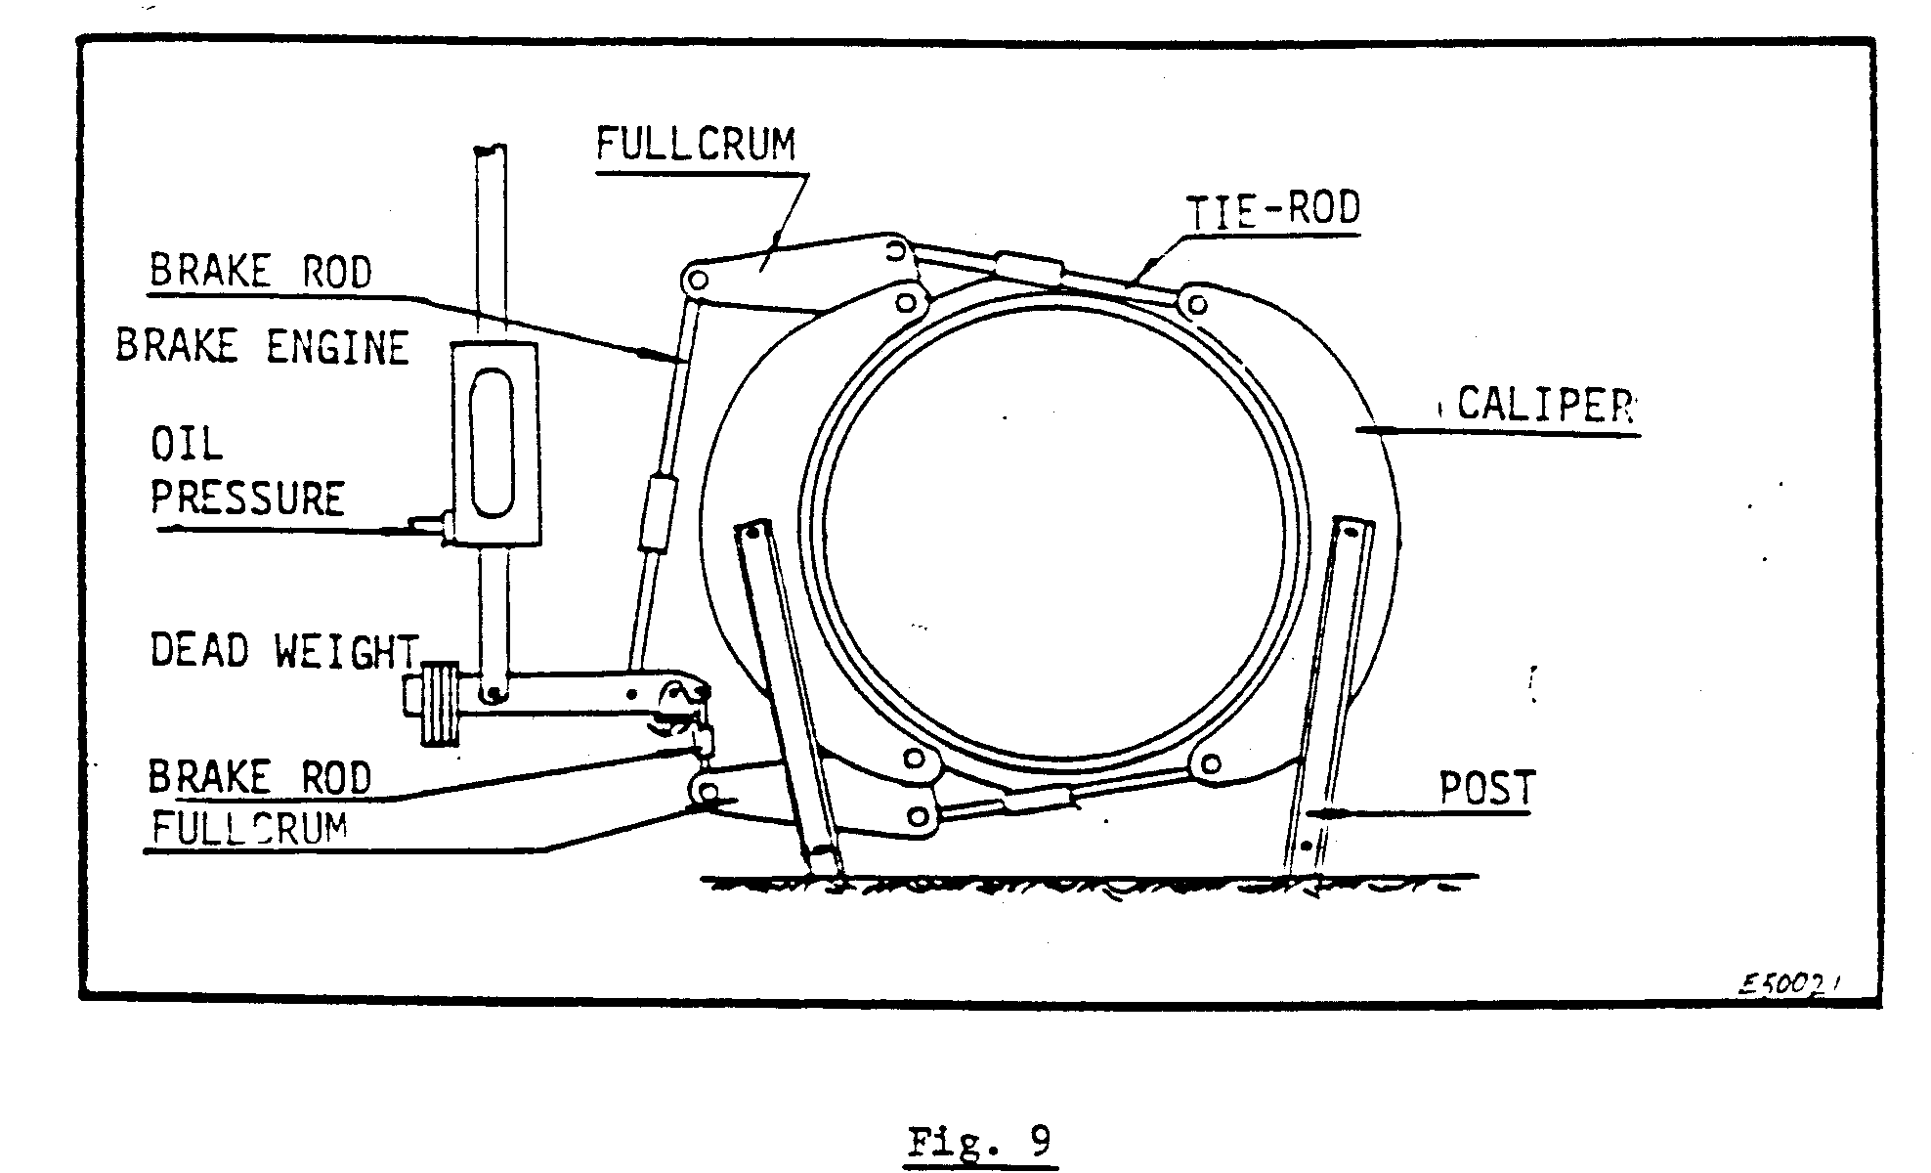
The brakes work with a scissors action. The weight applies the brakes and the oil pressure releases them, or in actual fact, due to the oil pressure in the brake engine the brakes are held away from brake path.
Constant oil pressure is required to operate the brakes and clutches. This pressure is maintained by an accumulator. The accumulator is charged by an oil pump, which pushes it up to, where a trigger arm opens a by-pass valve, allowing the oil to by-pass back to the tank. An accumulator is shown in Fig. 10.

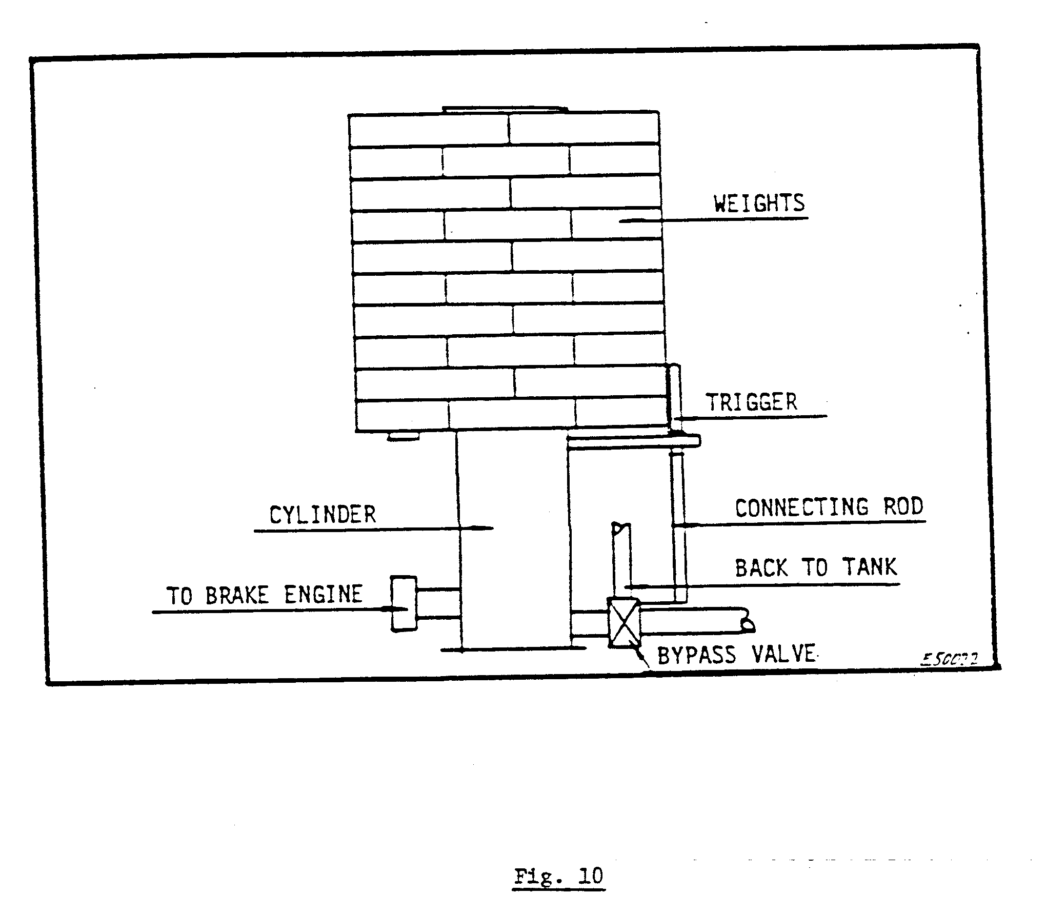

LINKS TO SERVO

When the Driver moves the control lever, the servo comes into operation via links, which actuate the valve on the servo. The valve in turn actuates the cylinder, which is connected to the liquid controller. The servo and liquid controller will be discussed in more detail in a later module, F.C.9 – 15(3).
In Fig. 11 the links from the Driver’s lever to the servo and liquid controller are shown.
